CTA Daily Ridership Data

This data set has the daily ridership entries for CTA stations in Chicago broken down by station and weekday, Saturday, or Sunday/Holiday. This will allow us to see which stations and lines are most used and what days they are most used on. This should allow us to see the differences between weekday and weekend transit patterns as well as see how special days (for example the Cubs World Series) impact the data. When this data is combined with data from the Bus system as well as the demographic data we should be able to see which communities in the city are underserved and which stations or areas require additional capacity.

Going forward, the largest issue we will likely face is combining this data set with the others so that we can get a clearer picture of the transit patterns in the city. However, the city of Chicago also provides geographic data for all of these stops so we should be able to use that as well. We should be able to use geographic visualization techniques as well as predictive techniques like regression analysis to predict what a new station's usage could be based on the surrounding demographic data.

Exploratory Visualizations:

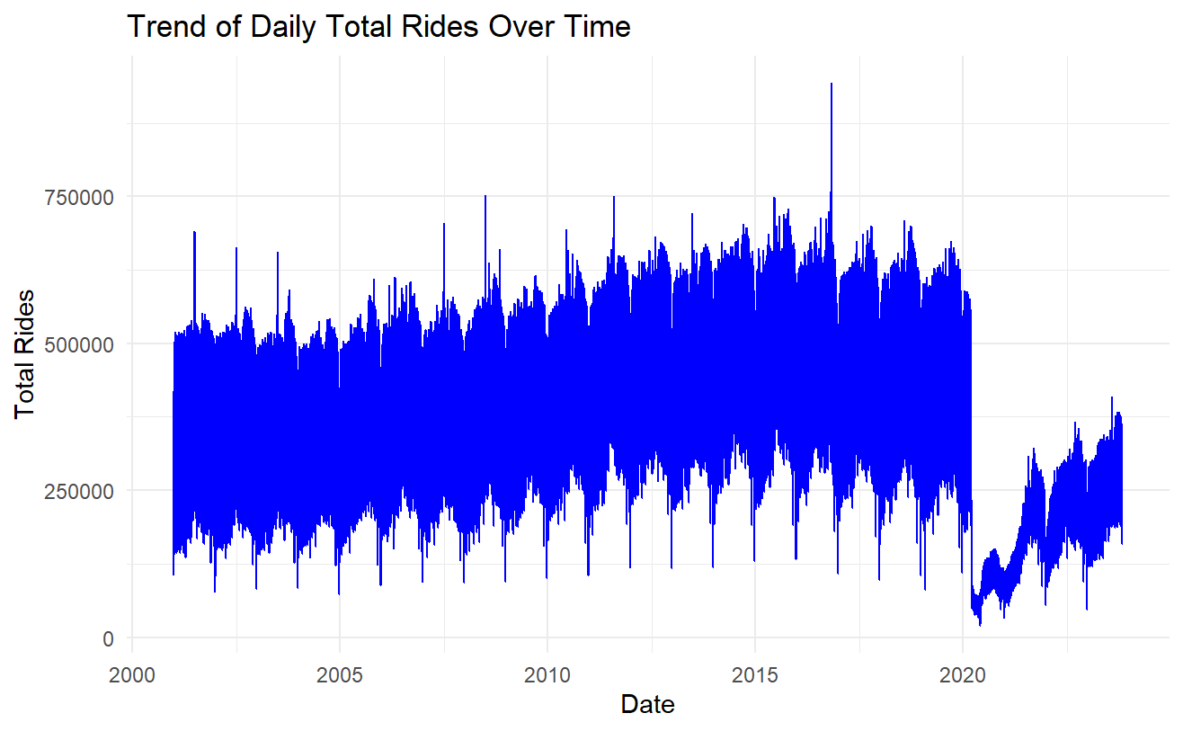

This graph shows how CTA Ridership has been impacted over the last 24 years. We can clearly see the massive impact that covid had as well as the large spike related to the 2016 Cubs World Series win.

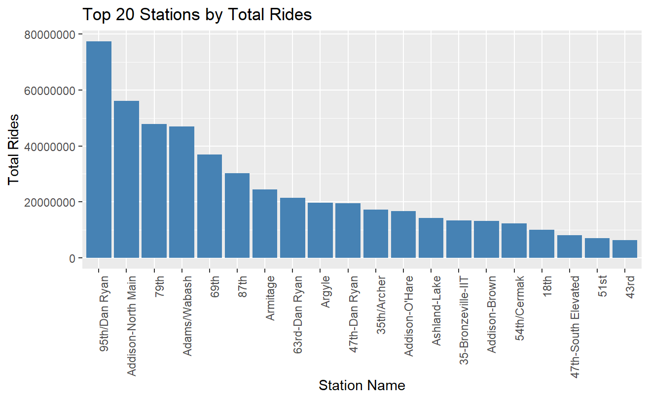

This graph shows the top 20 most used stations. We can see that 95th Dan Ryan is the most used. Since that is the last stop on the South side for the red line it likely is pulling in people from surrounding communities that do not have any other access to public transport. 79th St. The station is the next in the red line so it is likely having a similar effect. The Addison station is the main station to get to Wrigley Field which is why it would be the second most used.

The following graphs compare the differences between Weekday and Weekend/Holiday travel patterns. We can see that the overwhelming majority of travel is done during the week. By comparing the top stations for weekend and weekday travel we do see some differences such as Belmont and Addison (Both Cubs related stops) being higher on the weekend while stops that are more likely used for work commuting like 95th Dan Ryan are lower on the weekend.

